Final Game Computer Graphics

Jhoan Sebastián Marín Valencia

1112790853

Alejandro Osorio Trujillo

1088342470

Juan Pablo Ospina Bustamante

1088352624

Carlos Andrés López

Universidad Tecnológica de Pereira

Pereira, Risaralda

2018

**Inputs:**

To run the game, Python2 with pygame installed must be used.

Inside the source folder, run the following command

Python main.py

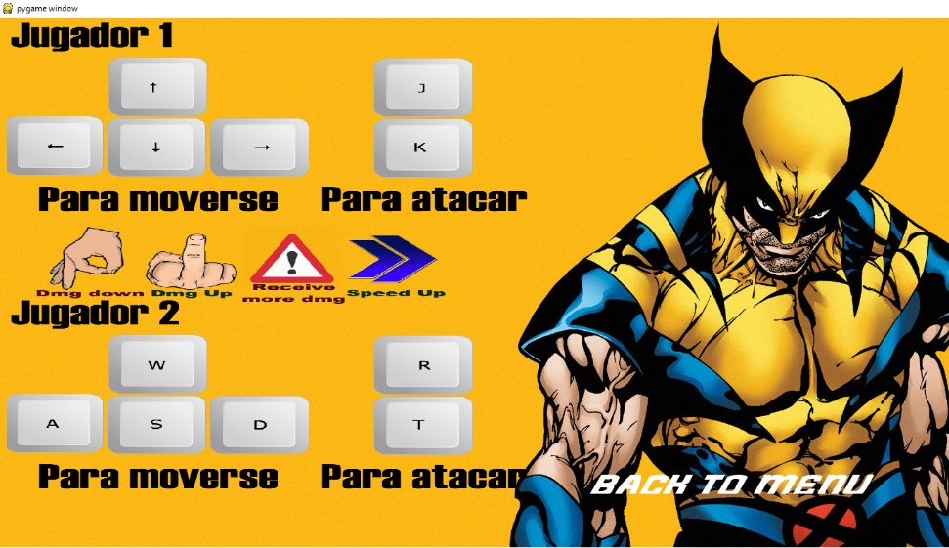

In the main screen, you can use the mouse to select options

2 Players can enjoy the game at the same time:

Player 1 Controls:

* **Arrows:** Move the player
* **J-K:** Light and Heavy attack

Player 2 Controls:

* **WASD:** Move the player
* **R-T:** Light and Heavy attack

**Outputs:**

The program will output the game, including graphics and sounds.

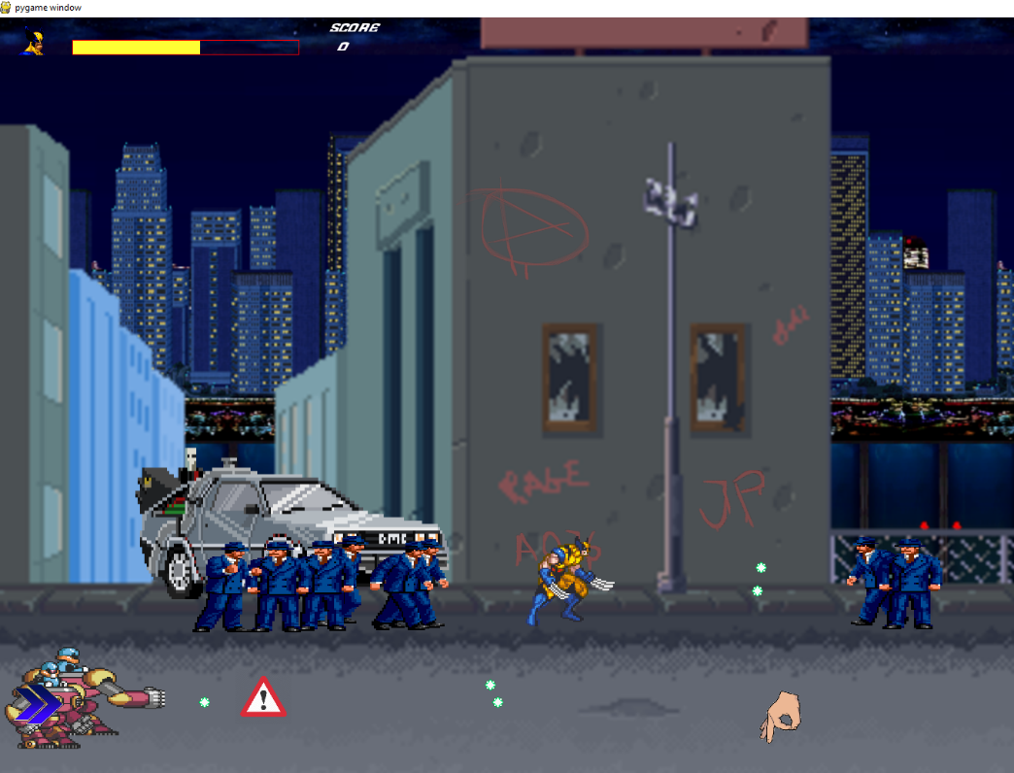

**Intent:**

This game was made with the intention of presenting it as a final project to the Computer Graphic’s course

**Scope:**

Consists of creating a game where 2 players can play at the same time, if chosen. Multiple enemies should appear on screen, from two possible types: static and mobile enemies.

Obstacles and projectiles are required, as well as power ups or other special items.

A boss battle is included, within the last level. There are 2 levels in total.

**Game Information:**

1. **Title:**  Wolverine: The Game.
2. **Designer and Programmers:** Jhoan Sebastián Marín Valencia, Alejandro Osorio Trujillo y Juan Pablo Ospina Bustamante.
3. **Genre:** Beat ‘em Up.
4. **Platform:** Personal Computer.

**3. Gameplay and Content Synopsis:**

The game has as its essence the melee fights, that is, at close range. Our main character, Wolverine, must fight his way through waves of varied enemies in order to save the world from impending destruction.

* 1. **Category:**

• Streets of Rage 2: It has similarities with the game in space movement and in the generation of enemies.

• X-men Reign of Apocalypse: It presents similarities in the theme of the game, being Wolverine one of the characters of the mentioned game.

• X-men (1992): The theme and spatial management of the scenario are similar.

The game presented in this document differs due to its bizarre characteristics, such as the choice of images that make up the modifier items as well as a mixture of themes between various video games through the indiscriminate use of sprites (if it is favorable), the drawing of various items within the game, in addition to their unique designs.

* 1. **License:**

The game is original in Description but not in resources, the sprites used are of the character of Wolverine, more specifically an 8-bit design; used enemies are obtained from various sources as well. The game is licensed under the MIT type and format.

* 1. **Mechanics**:

The player moves around the map hitting his enemies with two types of attacks, in addition there are 4 types of power-ups that will help or harm the player depending on the type of the same power-up.

* 1. **Technology:**

The Python programming language is used and the I <3 IMG web page is used to help with cutting images.

Regarding the hardware, three computers were used:

• MacBook pro 13 ': 2.7 GHz Intel Core i5 Dual Core processor, 8 GB of 1866 MHz LPDDR3 integrated memory, Intel Iris Graphics 6100.

• Asus X455L: 2.6 GHz Intel Core i7 Dual Core processor, 8GB of memory, Nvidia GeForce 820M with 1GB and Intel HD Graphics 4400.

• Lenovo idea pad 320: Intel Core i5 Dual Core 2.4 Ghz, 4 GB of memory and Intel HD Graphics 520.

* 1. **Target Audience:**

The game can be played by people of all ages, but it is more aimed at an audience of 13-17 years, more specifically college students, an audience with moderate time intervals, so the story is simple and more focused in the realm of the game.

1. **Version History:**

**Current Version: 3.0**

**Changes in comparison to previous versions:**

**• Version 1.0:** Creation of the document describing in a very basic way the structure of the document.

**• Version 1.1:** Added a short description of the types of enemies found in the game.

**• Version 1.2:** Adhesion of diagrams explaining the states of the game.

**• Version 2.0:** Deepening the description of the enemies, adding images for the description of game interfaces.

**• Version 2.1:** Description of the game mechanics, overview and some elements of the game Description.

**• Version 3.0:** Completion of the game Description; addition of game levels (one, two and final level), inclusion of characters, weapons, items, game history and the rest of the missing elements.

1. **Game Overview:**

Wolverine: The Game tells the story of a well-known hero, logically as the name says, it is Wolverine. The focus was to make our character feel powerful, as he can eliminate many enemies with his superhuman dexterity and strength; the public must be attracted to this game as it is a challenge, the player does not have things easy at all when moving around the map; As mentioned above, the player embodies Wolverine, recognized primarily for his sharp claws, the mission: Save the world from total annihilation by enemy forces.

1. **Game Mechanics:**
   1. **Camera:**

A 2D camera is used.

* 1. **Peripherals:**

Keyboard, Mouse and Screen.

* 1. **Controls:**

Arrows: Movement.

J, K: Attacks.

* 1. **Score:**

There is a local score table that is shown in each tour (Level), it will increase or decrease depending on the objectives achieved.

* 1. **Saving/Loading:**

The game does not have a saving or loading system.

1. **Game states:**

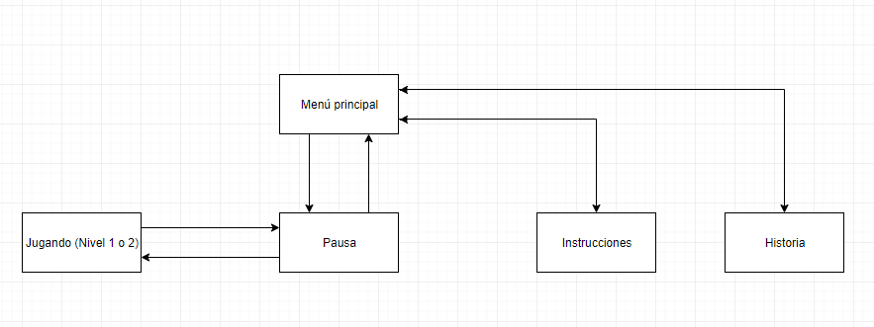

**• Main menu:** The main menu interface is displayed with all selectable options (Level 1, Level 2, Instructions, History and Exit).

**• Playing (Level 1 or 2):** The background is shown, depending on the level, with the player's Sprite and the enemies present.

**• Pause:** The background is shown, depending on the level, with the player's Sprite and the enemies present, but in a waiting state, that is, it is not possible to move, only to play again or exit to the main menu.

**• Instructions:** The main menu interface is shown, but with some instructions about the game controls.

**• History:** The main menu interface is shown, but with a summary of the game's history.

1. **Interfaces:**

**Menu:**

* 1. Screen Name: Options Menu
  2. Screen description: Yellow background screen with Wolverine in his recognized suit on the right side; It consists of different selectable options
  3. Game states: The player is in the game state of the main menu, he can call up the options to play (Single player), view instructions, view the history of the game and exit.
  4. Image:

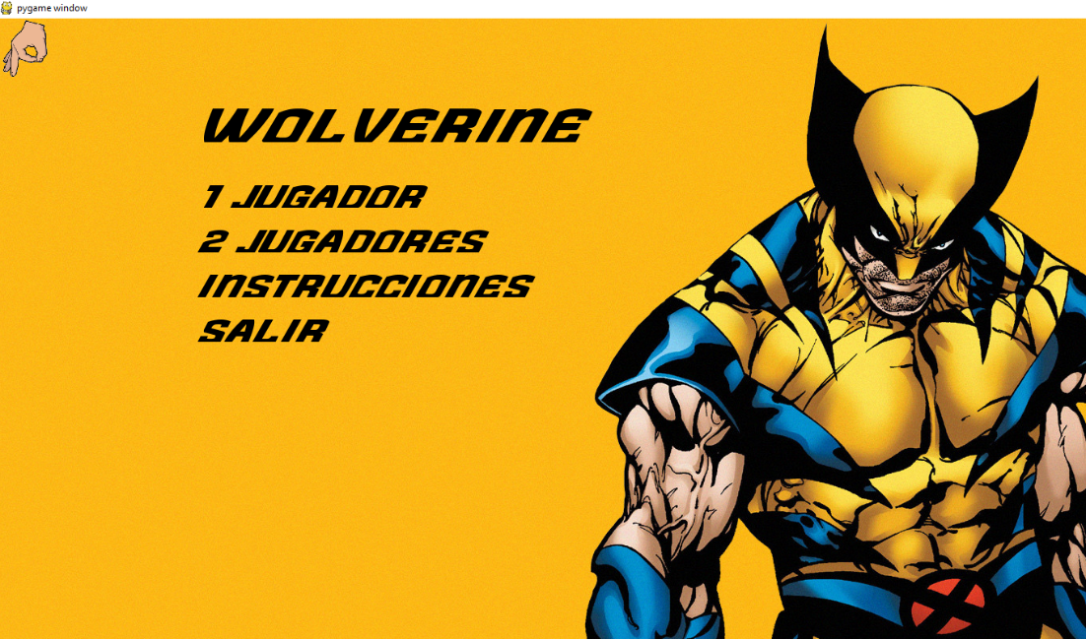

**Pause:**

1. Screen Name: Pause Menu
2. Screen Description: Background screen of the level you are in, but totally paused.
3. Game States: The player is in the pause game state, so it will not be possible to move the character.
4. Image:

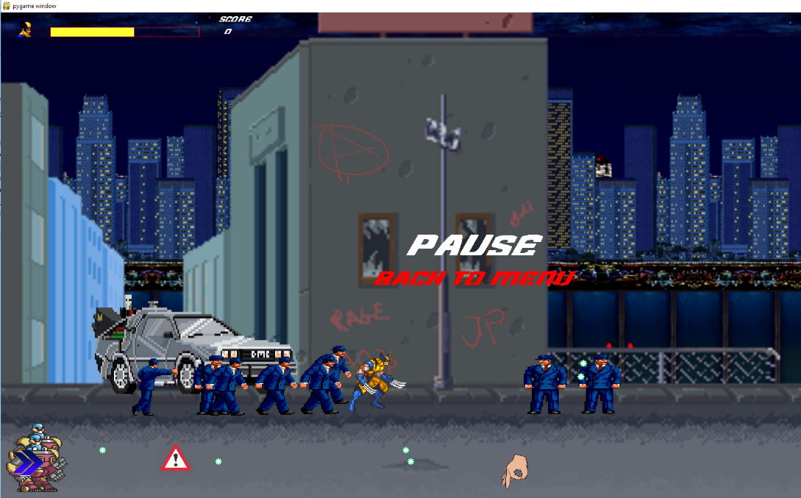

**Levels:**

1. Screen Name: Level 1-2.
2. Screen Description: Background screen with the Sprite for a certain level (City).
3. Game States: The player is in the active game state, can evoke the pause option.
4. Image:



**Instructions:**

1. Screen Name: Instructions
2. Screen Description: Yellow background screen with Wolverine in his recognized suit on the right side; It consists of an Image with the game controls.
3. Game States: to. The player is in the game state of the main menu in the instructions option, can evoke the options to return to the main menu.
4. Image:



**Story:**

1. Screen Name: Story
2. Screen Description: Yellow background screen with Wolverine in his recognized suit on the right side; It consists of a few paragraphs explaining the history of the game.
3. Game States: The player is in the game state of the main menu in the story option, can evoke the options to return to the main menu or to go on to play the game.
4. Image:

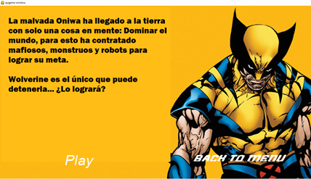

1. **Level:**

**Nivel 1:**

* 1. **Level Title:** Start your mission.
  2. **Encounter:** First Level
  3. **Description:** Wolverine must make his way through the infested city of New York, a city a bit destroyed since the enemy forces have already arrived there.
  4. **Objectives:** The player must kill all the enemies in each wave and reach the end of the map in order to advance.
  5. **Progress:** An interlude is shown and continues to the next level.
  6. **Enemies**
* **Mobile:** Thug.
* **Static:** Red Robot.
  1. **Items**
* Modifier 1.
* Modifier 2.
* Modifier 3.
* Modifier 4.
* Modifier 5
* Modifier 6.
  1. **Characters:** Wolverine as a playable character, in addition to enemies
  2. **Music and Sound effects:**

The music of the level plays (8-bit games type), in addition all the sound effects associated with the player (Wolverine) and the enemies Red Robot and Thug will sound.

* 1. **BGM and SFX References:**
* <https://www.google.com/url?hl=es-419&q=https://archive.org/details/Saladedemais_-_Follin_Project_-_NES/46.%2BWolverine%2B-%2BLevel%2BBGM%2B01.mp3&source=gmail&ust=1527791939716000&usg=AFQjCNExMq1AEYVi1xIMoRLMp74CteBgXw>
* <http://soundbible.com/tags-step.html>
* <https://www.youtube.com/watch?v=wPljMykGkZ0>
* <http://soundbible.com/tags-punch.html>
* <http://soundbible.com/tags-explosion.html>

**Level 2:**

1. **Level Title**: Kill the boss.
2. **Encounter:** Second level including Boss
3. **Description:** Wolverine must defeat all the lackeys of the enemy boss; at the end of the level, he must defeat the boss himself to save the whole world.
4. **Objectives:** The player must kill all the enemies in each wave, kill the final boss and reach the end of the map in order to advance.
5. **Enemies:**

* Mobile: Rhett Butler.
* Static: Turret.
* Boss: Oniwa.

1. **Items**

* Modifier 1.
* Modifier 2.
* Modifier 3.
* Modifier 4.
* Modifier 5.
* Modifier 6.

1. **Characters:** Wolverine as a playable character, in addition to the enemies.
2. **Music and Sound Effects:** The music of the level plays (8-bit games type), in addition all the sound effects associated with the player (Wolverine) and the enemies Rhett Butler, Turret and Oniwa will sound.
3. **BGM and SFX References:**

* <https://www.google.com/url?hl=es-419&q=https://archive.org/details/Saladedemais_-_Follin_Project_-_NES/46.%2BWolverine%2B-%2BLevel%2BBGM%2B01.mp3&source=gmail&ust=1527791939716000&usg=AFQjCNExMq1AEYVi1xIMoRLMp74CteBgXw>
* <http://soundbible.com/tags-step.html>
* <https://www.youtube.com/watch?v=wPljMykGkZ0>
* <http://soundbible.com/tags-sword.html>
* <http://soundbible.com/tags-gun.html>
* <http://soundbible.com/tags-explosion.html>

1. **Game Progress:**
2. Finish Level 1.
3. Finish Level 2.
4. End of Game.
5. **Characters:**
   1. **Character’s Name:** Wolverine.
   2. **Description:** Short, muscular human in a yellow and blue suit; three sharp silver claws emerge from each of his hands.
   3. **Image** <https://santigesualdo.wordpress.com/2014/01/23/ultimas-actualizaciones-juego-wolverine/>





* 1. **Description:** Protagonist of the game, his main motivation is his desire to defend the defenseless; In this case, his main objective is to save the world since no one else can do it (The other heroes are dead, because of his regenerative power he is the only survivor).
  2. **Encounter:** Appears at the start of the game.
  3. **Abilities**
* Walk.
* Attack with right arm.
* Attack with left arm.
  1. **Weapons:** His claws.
  2. **Items:** It does not present its own objects as such, only the Game Modifiers.

1. **Enemies:**

**Mobile Enemy 1:**

* 1. **Name:** Thug.
  2. **Description:** A gangster in a hat dressed in blue is a robot with this appearance.
  3. **Encounter:** First Level.
  4. **Image** <http://spritedatabase.net/file/16839/Thug>





* 1. **Abilities:**
* Walk.
* Melee attacks.
  1. **Weapons:** His Fists.
  2. **Items:** None.

**Static Enemy 1:**

* 1. **Name:** Red robot.
  2. **Description:** A very futuristic robot, equipped with a very resistant red metal armor.
  3. **Encounter:** First Level.
  4. **Image** <http://www.sprites-inc.co.uk/sprite.php?local=X/X1/Enemy/>

enemyFace1.png

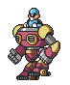

* 1. **Abilities:**
* Shoot plasma bullet.
  1. **Weapons:** A cannon on his arm.
  2. **Items:** None.

**Mobile Enemy 2:**

1. **Name:** Rhett Butler.
2. **Description:** Mutant werewolf of great size and resistance.
3. **Encounter:** Second level.
4. **Image** <https://www.spritersresource.com/arcade/prettysoldiersailormoon/sheet/34780/?source=genre>

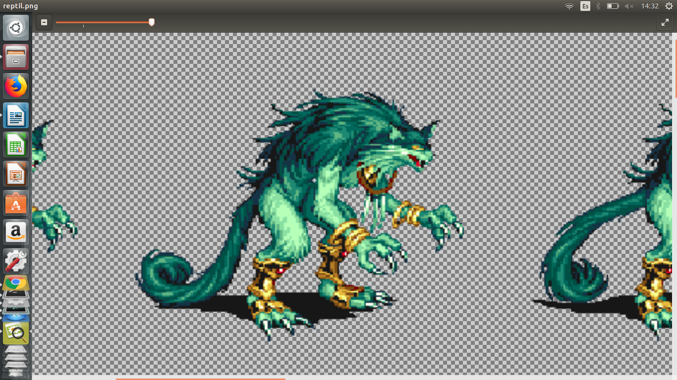



1. **Abilities**

* Walk.
* Close melee attack.

1. **Weapons:** Its claws.
2. **Items:** None.

**Static Enemy 2:**

1. **Name:** Turret
2. **Description:** Mechanical turret that comes out of the ground upon sensing an enemy.
3. **Encounter:** Second level.
4. **Image** <http://spritedatabase.net/file/20737/Turret>

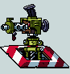

1. **Abilities**

* Shoot.
* • Exit and enter a level ground compartment.

1. **Weapons:** A weapon itself.
2. **Items:** None.

**Jefe final**

1. **Name:** Oniwa.
2. **Description:** Leader of a gang of gangsters, expert in weapons and melee attacks.
3. **Encounter:** Second level.
4. **Image** <https://www.spritersresource.com/arcade/prettysoldiersailormoon/sheet/35778/?source=genre>

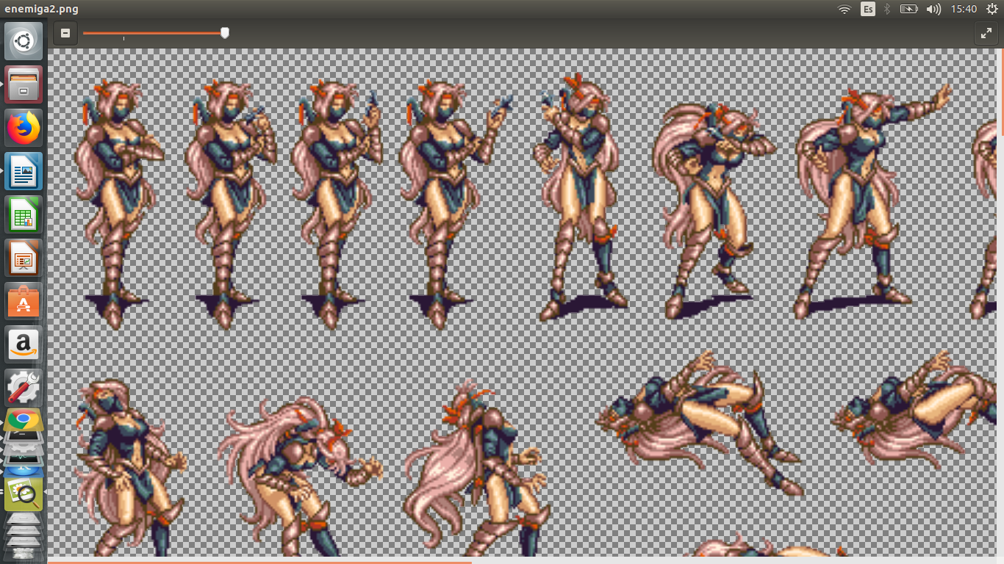



1. **Abilities:**

* Melee attack.
* Throw darts and grenades.

1. **Weapons:**

* Ninja sword.
* Darts and grenades.

1. **Items:** None
2. **Abilities:**
   1. Player

* Walk.
* Attack.
  1. Enemies
* Walk.
* Melee attack.
* Shoot plasma bullet.

1. **Weapons:**
   1. Wolverine wields his sharp adamantium claws as weapons.
   2. Plasma cannon in the robot’s arm.
2. **Items:**

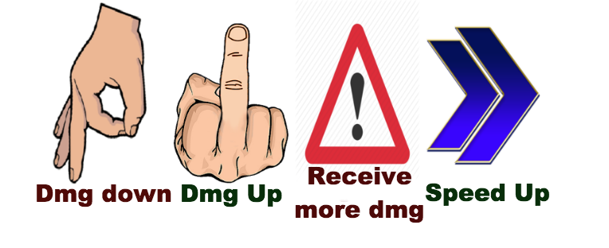



* 1. Modifier 1: Lowers player damage.
  2. Modifier 2: Increases player damage.
  3. Modifier 3: Player takes more damage from enemies.
  4. Modifier 4: The player increases their speed.
  5. Modifier 5: The player restores part of their health.
  6. Modifier 6: The player fully restores their health.

1. **Script:**

The game has no dialogue.

1. **Achievements:**

The game has no achievements, except for winning.

1. **Secret codes:**

The game does not have secret codes.

1. **Music and sounds:**

M1. Music main menu: An 8-bit game-type musical atmosphere is heard.

M2. Music level 1: An 8-bit game-type musical atmosphere is heard.

M3. Music level 2: An 8-bit game-type musical atmosphere is heard.

S1. Attack 1 Wolverine: Sound like a blade.

S2. Attack 2 Wolverine: Sound like a blade.

S3. Walking Wolverine: Very smooth footsteps are heard with every movement.

S4. Positive Modifier: A distinctive sound is heard when a beneficial Modifier is obtained.

S5. Negative Modifier: A distinctive sound is heard when a Modifier is obtained that negatively affects the player.

S6. Steps Mobile Enemy 1: Footsteps from high heels are heard.

S7. Mobile Enemy Hit 1: A fist sound is heard.

S8. Explosion (Fixed Enemy Death 1): When your health level is less than or equal to 0, an explosion sound.

S9. Turret Shot: A firearm shot sounds.

S10. Turret exit: A robotic sound when exiting the floor.

S11. Monster steps: Heavy steps sound.

S12. Monster Attack: Fists sound.

S13. Steps boss: Steps are heard.

S14. Boss attack: A characteristic attack of the final boss is heard.

1. **Description Images:**

There is no Description art, all the character and level designs were downloaded from the internet.

1. **Team Members:**
   1. Jhoan Sebastián Marín Valencia: Programmer.
   2. Alejandro Osorio Trujillo: Programmer and Designer.
   3. Juan Pablo Ospina: Programmer, Designer and Team Leader
2. **Production Details:**
   1. **Start Date:**

May 10, 2018.

* 1. **End Date:**

June 4, 2018.

* 1. **Budget:**

There is no financial budget for the development of the game.